Dear Applicant

Equalities Monitoring

Thank you for your interest in the recent vacancy at this school. The school operates an equalities policy to ensure that all staff and applicants receive fair and equal treatment at all times. As part of this policy it is essential that we monitor the profile of our applicants in relation to gender, ethnic origin, disability, sexual orientation and age.

The enclosed form is designed to record and monitor the relevant data for this monitoring process. I would be very grateful if you could complete the form and return it to me in the enclosed envelope when you submit your application.

The information on this form will be used for statistical purposes only and will not form any part of a record on you as an individual unless you are subsequently appointed to the school, in which case it may be held as part of a computerised personnel record on the school’s HR system which is available for your inspection.

I am making this request in accordance with the recommendations of the Equality and Human Rights Commission. However, if you wish to discuss the content of the form or the use of the data, please let me know.

Yours sincerely
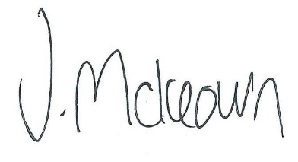

Mrs J Mckeown
Executive Headteacher

